DATA SCIENCE PORTFOLIO PROJECT
TELECOM CUSTOMER
CHURN & RETENTION
ANALYTICS
Customer behaviour • Churn risk • Retention opportunities
Headline result: 26.54% of 7,043 customers churned; month-to-month and first-year customers showed the highest observed churn.

Project detail | Description
Dataset | IBM Telco Customer Churn (7,043 rows × 21 columns)
Tools | Microsoft Excel, MySQL, Python (Pandas, NumPy, Matplotlib, Seaborn), Power BI
Objective | Analyze customer churn, identify high-risk customer segments, and recommend data-driven retention strategies
Audience | Data science internship evaluators, recruiters, and technical interviewers
Report type | Descriptive analytics report (observed associations; no causal claims)
Document status | Draft for review before PDF export
Prepared as a portfolio project

Table of Contents
1. Executive Summary 3
2. Project Objectives and Scope 3
2.1 Objectives 3
2.2 Scope 3
3. Dataset Overview 4
4. Methodology and Tools 4
4.1 Python workflow 4
4.2 Metric approach 5
5. Data Quality and Preparation 6
5.1 Missing TotalCharges values 6
5.2 Data-validation note: MySQL Churn field 6
6. Key Findings 6
6.1 Overall churn 6
6.2 Churn by contract type 6
6.3 Churn by tenure group 7
6.4 Monthly charges by churn status 8
6.5 Additional segment observations 8
7. Business Interpretation 9
7.1 Association versus causation 9
8. Recommendations 9
8.1 Early-stage onboarding and retention campaigns 9
8.2 Test longer-term contract incentives 9
8.3 Investigate billing, service quality, and support 9
8.4 Monitor outcomes 10
9. Power BI Dashboard Design and Usage 11
9.1 Dashboard components 11
9.2 Suggested layout 11
9.3 Usage guidance 11
10. Limitations 11
11. Conclusion 12
Appendix A: KPI Definitions 12
Appendix B: Project Deliverables Checklist 12

1. Executive Summary
This report analyses customer churn in the IBM Telco Customer Churn dataset. It measures overall churn and retention, compares churn across contract types, tenure groups, and selected service and payment segments, and translates the observed patterns into practical retention recommendations.
Overall KPI | Result
Total customers | 7,043
Churned customers | 1,869
Retained customers | 5,174
Overall churn rate | 26.54%
Retention rate | 73.46%
Table 1. Overall customer KPIs.
Key observations:
- Contract type. Month-to-month customers have the highest observed churn rate (42.71%), compared with 11.27% for one-year and 2.83% for two-year contracts.
- Tenure. Customers in their first 12 months churn at 47.44%, falling to 9.51% for customers with 49–72 months of tenure.
- Monthly charges. Churned customers have a higher average MonthlyCharges (74.44) than retained customers (61.27).
- Segments to investigate. Fiber optic internet, electronic-check payment, and customers without online security or tech support show elevated churn and warrant further analysis.
Important: All findings are descriptive associations. This analysis does not establish that contract type, tenure, charges, or any service feature independently causes churn.
The recommended priorities are early-stage onboarding and retention campaigns, carefully tested longer-term contract incentives, investigation of billing clarity, service quality and support experience, and ongoing monitoring of churn, retention, and intervention outcomes.

2. Project Objectives and Scope

2.1 Objectives
- Measure overall churn and retention using customer-level records.
- Compare churn rates across contract types and tenure groups.
- Compare average monthly charges between churned and retained customers.
- Examine additional segments such as internet service, payment method, online security, and tech support.
- Present results in an interactive single-page Power BI Executive Overview dashboard.
- Develop practical, testable retention recommendations.

2.2 Scope
The project covers descriptive analysis of one static dataset using four tools. It does not include predictive modelling, causal inference, customer-lifetime-value modelling, or controlled experiments.
Area | In scope | Out of scope
Analysis type | Descriptive KPIs and segment comparisons | Predictive or causal modelling
Data | IBM Telco Customer Churn dataset | External or time-series customer data
Outputs | Report, Excel, SQL, Python, Power BI | Deployed production system
Recommendations | Hypotheses and tests to run | Proven intervention results
Table 2. Project scope boundaries.

3. Dataset Overview
The source is the IBM Telco Customer Churn dataset, a customer-level dataset for a telecommunications provider. Each row represents one customer and includes account, service, billing, and churn-status information such as tenure, contract, internet service, payment method, MonthlyCharges, TotalCharges, and Churn.
Dataset attribute | Observed value
Rows (customers) | 7,043
Columns | 21
Unique customer IDs | 7,043
Duplicate rows | 0
Missing TotalCharges values | 11
Table 3. Dataset shape and data-quality checks.
The target variable is Churn. A customer with Churn = Yes is counted as churned; Churn = No is counted as retained. Derived analysis fields used in this report include tenure groups (0–12, 13–24, 25–48, and 49–72 months).

4. Methodology and Tools
The analysis follows a layered workflow in which each tool plays a distinct role: spreadsheet exploration, database validation, programmatic analysis, and executive reporting.
Tool | Role in the project
Microsoft Excel | KPI summary, grouped comparisons, pivot-style analysis, and charts.
MySQL | Data validation and business queries using grouping, filtering, and segmentation.
Python | Pandas and NumPy for data inspection, quality checks, and churn calculations; Matplotlib and Seaborn for visualization.
Power BI | One-page interactive executive overview with KPI cards, charts, and slicers.
Table 4. Tools and responsibilities.

4.1 Python workflow
- Import libraries and load the cleaned CSV (telco_churn_cleaned.csv).
- Inspect shape, data types, missing values, duplicate rows, and unique customer IDs.
- Calculate the overall churn distribution.
- Analyze churn by contract type and tenure group.
- Compare MonthlyCharges between churned and retained customers.
- Visualize churn rates and document business insights.

4.2 Metric approach
Churn rate for any segment is calculated as churned customers in the segment divided by total customers in that segment. All percentages in this report are shown to two decimal places. KPI definitions are listed in Appendix A.

5. Data Quality and Preparation
Quality checks were run before any segment analysis. The dataset has no duplicate rows and every customer ID is unique, so each record can be treated as one customer.
Check | Result | Handling
Dataset shape | 7,043 × 21 | Confirmed
Unique customer IDs | 7,043 | No duplicate customers
Duplicate rows | 0 | No action needed
Missing TotalCharges | 11 | Retained and flagged for review; not silently deleted
Table 5. Data-quality summary.

5.1 Missing TotalCharges values
Eleven records have missing TotalCharges values. These records were not silently deleted. Any decision to impute, exclude, or analyze them separately should be documented explicitly and should preserve the original records. Because the churn, contract, tenure, and MonthlyCharges analyses in this report do not depend on TotalCharges, the headline KPIs retain all 7,043 customers.

5.2 Data-validation note: MySQL Churn field
Validation note: During the MySQL import workflow, the Churn field showed a carriage-return normalization issue for the value “Yes”. SQL comparisons should use a normalized value (for example TRIM or a first-character check) until the field is cleaned and revalidated. This is an import-specific issue and should not be assumed to exist in the CSV loaded directly into Python or Power BI.

6. Key Findings

6.1 Overall churn
Of 7,043 customers, 1,869 churned and 5,174 were retained, giving an overall churn rate of 26.54% and a retention rate of 73.46%. Roughly one in four customers in the dataset churned.

6.2 Churn by contract type
Contract | Total customers | Churned customers | Churn rate
Month-to-month | 3,875 | 1,655 | 42.71%
One year | 1,473 | 166 | 11.27%
Two year | 1,695 | 48 | 2.83%
Table 6. Churn by contract type.
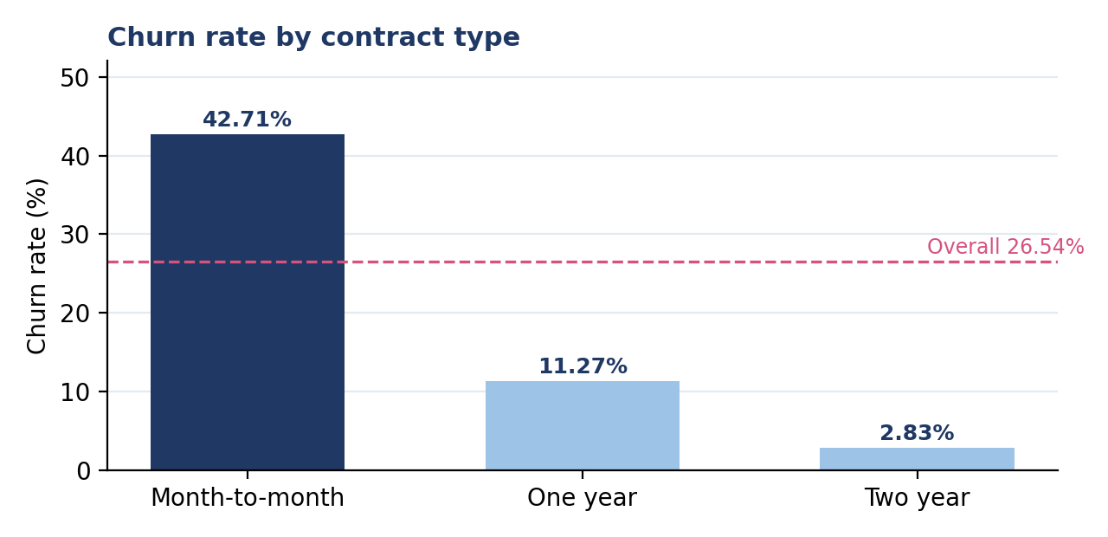
Figure 1. Contract-wise churn rate (dashed line = overall churn rate).
Month-to-month customers have the highest observed churn rate. They represent 55.02% of customers but 88.55% of all churned customers (derived from the table above). One-year and two-year contracts show much lower rates. Contract length is a useful segmentation variable for retention planning, but these figures alone do not show that contract type causes churn; customers who intend to stay may simply choose longer contracts.

6.3 Churn by tenure group
Tenure group | Total customers | Churned customers | Churn rate
0–12 months | 2,186 | 1,037 | 47.44%
13–24 months | 1,024 | 294 | 28.71%
25–48 months | 1,594 | 325 | 20.39%
49–72 months | 2,239 | 213 | 9.51%
Table 7. Churn by tenure group.
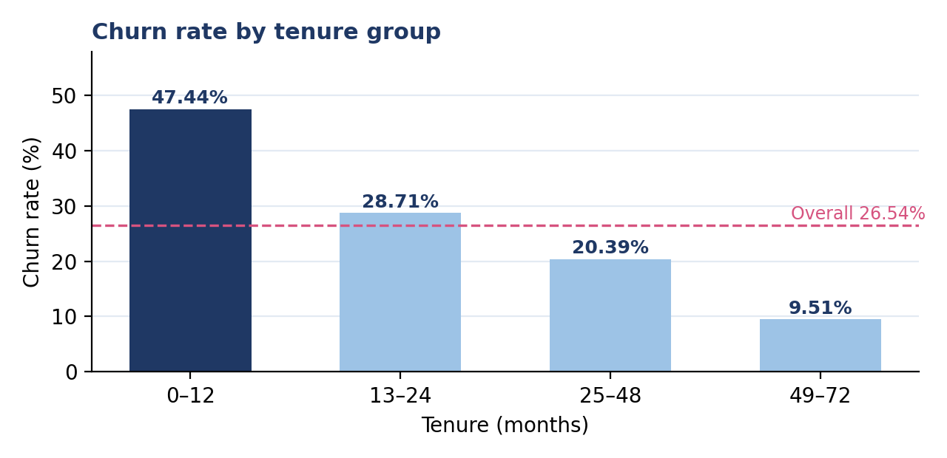
Figure 2. Tenure-wise churn rate (dashed line = overall churn rate).
Churn declines steadily as tenure increases. Customers in the first 12 months account for 31.04% of customers and 55.48% of churned customers (derived), making this the highest-priority segment in the observed data.

6.4 Monthly charges by churn status
Customer status | Average MonthlyCharges
Retained customers | 61.27
Churned customers | 74.44
All customers | 64.76
Table 8. Average monthly charges by customer status.
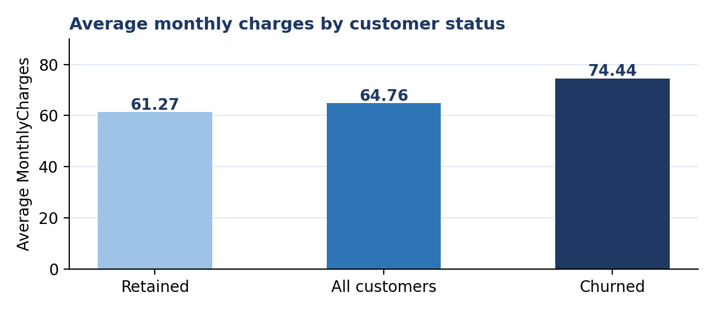
Figure 3. Average monthly charges for retained, all, and churned customers.
Churned customers pay 13.17 more per month on average than retained customers (about 21.50% higher, derived). This may reflect service mix, value perception, or support experience, but price alone should not be assumed to be the cause.

6.5 Additional segment observations
Dimension | Segment | Churn rate
Internet service | Fiber optic | 41.89%
Internet service | DSL | 18.96%
Internet service | No internet service | 7.40%
Payment method | Electronic check | 45.29%
Payment method | Automatic bank transfer | 16.71%
Payment method | Automatic credit card | 15.24%
Payment method | Mailed check | 19.11%
Online security | Without online security | 41.77%
Online security | With online security | 14.61%
Tech support | Without tech support | 41.64%
Tech support | With tech support | 15.17%
Table 9. Churn by additional segments (highest-churn segment in each dimension highlighted).
Fiber optic customers churn at 22.93 percentage points more than DSL customers, and electronic-check users churn at 28.58 percentage points more than automatic bank-transfer users (derived). These segments overlap and may reflect other customer characteristics, so they should be treated as hypotheses for deeper analysis before any targeting or pricing decision.

7. Business Interpretation
The findings point to where retention effort is most likely to matter. Each interpretation below is framed as an observed association with a suggested follow-up, not a proven cause.
Finding | What the data shows | Suggested interpretation
Contract risk | Month-to-month churn is 42.71% versus 2.83% for two-year contracts. | Month-to-month customers have the lowest commitment and are the largest at-risk pool.
Early-tenure risk | Churn is 47.44% in the first 12 months and 9.51% at 49–72 months. | The first year is a critical window for onboarding and service experience.
Charge level | Churned customers average 74.44 versus 61.27 for retained. | Value perception, service mix, or billing may deserve review; not proof of price sensitivity.
Service and payment | Elevated churn for fiber optic, electronic check, no online security, no tech support. | Candidate areas to examine for service quality, billing clarity, and support gaps.
Table 10. Business interpretation summary.

7.1 Association versus causation
This is a descriptive analysis of observational data. Customers are not randomly assigned to contract types, payment methods, or services, so differences between segments may be explained by other factors. For example, customers who already plan to stay may choose annual contracts, and segments such as fiber optic users may differ in price, usage, or location. Establishing causes would require controlled tests or more rigorous statistical modeling.
Reading guide: Statements such as “higher churn among X” describe what was observed. They do not mean that X independently causes churn.

8. Recommendations
Recommendations are prioritized by the size of the observed churn gap. Each should be treated as a hypothesis to test and measure.

8.1 Early-stage onboarding and retention campaigns
Design an early-retention journey for customers in their first 12 months: onboarding check-ins, proactive issue resolution, service-use guidance, and satisfaction reviews. Define a baseline first-year churn rate and measure the change after launch.

8.2 Test longer-term contract incentives
Offer selected month-to-month customers clear, optional benefits for moving to longer contracts. Use a controlled test with a comparison group to confirm that the offer improves retention without eroding margin.

8.3 Investigate billing, service quality, and support
Review billing clarity, complaints, service quality, and support interactions for higher-charge customers and for the fiber optic, electronic-check, no-online-security, and no-tech-support segments. Avoid blanket discounts until the drivers of churn are better understood.

8.4 Monitor outcomes
Track churn rate, retention rate, first-year churn, contract mix, and monthly charges of churned customers over time, together with the outcomes of each intervention.
Priority | Action | Success measure
1 | Early-tenure onboarding and retention campaign | First-year (0–12 month) churn rate
2 | Contract-incentive test for month-to-month customers | Churn and margin versus control group
3 | Billing, service, and support investigation | Findings documented; follow-up tests defined
4 | Ongoing monitoring | Churn and retention rate trend; intervention results
Table 11. Recommendation roadmap.

9. Power BI Dashboard Design and Usage
The Power BI deliverable is designed as a single-page Executive Overview. It lets a business reader see headline churn performance at a glance and explore segments using slicers.

9.1 Dashboard components
Component | Purpose
KPI cards | Total Customers (7,043), Churned Customers (1,869), Retained Customers (5,174), Churn Rate (26.54%), Retention Rate (73.46%).
Contract-wise churn chart | Compares churn across month-to-month, one-year, and two-year contracts.
Tenure-wise churn chart | Shows how churn falls across the four tenure groups.
Monthly-charge analysis | Compares MonthlyCharges between churned and retained customers.
Customer-segment slicers | Lets the viewer filter the whole page by available customer segments.
Table 12. Executive Overview dashboard components.

9.2 Suggested layout
- Top row: five KPI cards, displayed as exact values (not abbreviated).
- Middle: contract-wise and tenure-wise churn charts side by side.
- Lower section: monthly-charge analysis.
- Side or top panel: segment slicers.

9.3 Usage guidance
- Start with slicers set to All; the cards should match the KPIs in Table 1.
- Select a segment to see how churn rate, counts, and charge patterns change.
- Read segment results as associations; small segments can produce unstable rates.
Validation status: This report describes the dashboard design. The dashboard file itself has not been independently audited as part of this report. Before submission, confirm that card values match this report, that chart rates match Tables 6 and 7, and that slicers behave as expected.

10. Limitations
- The analysis is descriptive and does not establish causation.
- The dataset is a single static snapshot; findings may not generalize to other telecom companies, regions, or time periods.
- Segments overlap (for example, fiber optic and electronic-check customers), so single-factor comparisons can be confounded.
- The 11 missing TotalCharges values need documented handling if that field is used in further calculations.
- The MySQL Churn-field normalization issue means SQL comparisons need normalized values until the field is revalidated.
- No predictive model, statistical significance testing, or controlled experiment is reported.
- Completion and quality of individual project deliverables have not been independently audited in this report (see Appendix B).

11. Conclusion
Overall churn in the IBM Telco Customer Churn dataset is 26.54%, with retention at 73.46%. Churn is concentrated among month-to-month customers (42.71%) and customers in their first 12 months (47.44%), and churned customers have a higher average monthly charge (74.44 versus 61.27).
These results give a clear, evidence-based starting point for prioritizing early-tenure retention, testing contract incentives, and investigating billing, service, and support experience. Because the analysis is descriptive, the natural next step is to run controlled tests and, where appropriate, more rigorous modeling to learn which interventions actually reduce churn, and to monitor results over time.

Appendix A: KPI Definitions
KPI | Definition
Total Customers | Count of customer records in the analysis dataset.
Churned Customers | Count of records where Churn = Yes.
Retained Customers | Count of records where Churn = No.
Churn Rate | Churned Customers ÷ Total Customers (overall or within a segment).
Retention Rate | Retained Customers ÷ Total Customers.
Average MonthlyCharges | Mean of MonthlyCharges for the customer group being analyzed.
Tenure Group | Customer tenure in months, grouped as 0–12, 13–24, 25–48, and 49–72.
Table 13. KPI definitions.
Worked example: overall churn rate = 1,869 ÷ 7,043 = 26.54%; retention rate = 5,174 ÷ 7,043 = 73.46%.

Appendix B: Project Deliverables Checklist
Statuses below are deliberately conservative. Items are not marked complete unless verified; before submission, update this checklist against the actual project folder, verify all metrics, and export the reviewed report to PDF.
Deliverable | Expected filename | Status
Project report | 01_Project_Report.docx / .pdf | Word draft; review, then export to PDF
Excel analysis | 02_Excel_Analysis.xlsx | Not verified here; confirm
SQL queries | 03_SQL_Queries.sql | Not verified here; confirm
Python EDA | 04_Python_EDA.ipynb | Not verified here; confirm
Power BI dashboard | 05_PowerBI_Dashboard.pbix | Not independently audited; confirm
Presentation | 06_Presentation.pptx | Pending / unverified
README | 07_ReadMe.pdf | Pending / unverified
Table 14. Deliverables checklist (statuses to be confirmed by the author).

